June 4, 2026
The Coregonine Steering Committee is pleased to announce a call for proposals for FY27. Funding is typically available between May-August 2027, depending on agency.
The committee is prioritizing project proposals that are tightly aligned to the Coregonine Restoration framework (see image on Page 2). Note that coregonine restoration efforts are occurring in three lakes (Bloater in Lake Ontario, Cisco in Lake Huron, Cisco in Lake Erie). Two lake committees have also requested planning steps to be implemented for multiple species: Ontario (Bloater, Cisco, Lake Whitefish, Round Whitefish) and Michigan (Cisco, Kiyi). Specific priorities for this funding cycle include:
- Supporting science planning (aligned with orange boxes) in support of lake committee requests.
- Operational support to implement existing restoration efforts (green boxes).
- Supporting evaluation (blue boxes) of existing restoration efforts. Ideally one cooperative project will be received from each lake or lake technical committee or working group.
- Providing science support for enhanced quality of hatchery-reared fish for reintroduction efforts. Note that collaboration with Fish and Wildlife Service hatchery personnel is strongly encouraged.
  - Determine how to maximize survival of stocked fish after entering the lake.
  - How can productivity of captive Bloater broodstock be maximized? Currently viability of gametes from captive broodstock is significantly lower than gametes from wild-collected Bloater.
  - Explore the feasibility of alternative gamete sources for coregonine reintroduction efforts, specifically Cisco and Kiyi.
  - Develop and operationalize alternative marking strategies to measure survival of different life stages or gamete sources that are reintroduced.
- Coregonine spawning habitat: evaluate the effectiveness of different spawning habitat remediation approaches (e.g., adding or altering substrate, cleaning reefs). Studies that span gradients of anthropogenic stressors (i.e., mussel density, sedimentation) are encouraged.
Other considerations:
- Additional years of funding for previously funded projects that are making significant progress can be considered. Investigators need to clarify what has been completed with previous year funds and what new or complementary work would be completed with new funds.
- Proposals outside of these priorities can still be considered. We welcome other novel ideas that can advance elements of coregonine restoration, including science planning or operation.
- We highly encourage collaboration with university and agency scientists to increase the number and diversity of skill sets of coregonine scientists working in the basin.
- The details for the required proposal format are provided below (note strict 3-page limit).
- Prior to developing a proposal, it is highly recommended that you reach out to your agency coordinator to ensure 1) the scope of the proposal has sufficient merit or alignment with the priorities and 2) no duplication of similar proposals within or between agencies (we may direct you to work with other investigators in this instance). Proposals submitted without prior contact to your agency coordinator run the risk of not being considered by the Coregonine Steering Committee.
  - USGS: Bo Bunnell (dbunnell@usgs.gov)
  - FWS: Jessica Hogrefe (jessica_hogrefe@fws.gov)
  - BIA: Chase Meierotto (chase.meierotto@bia.gov)
  - NPS: Rick Damstra (Richard_Damstra@nps.gov)
  - Note- proposals originating from other federal agencies (e.g., NOAA) should reach out to Bo Bunnell or Jessica Hogrefe for more information but direct funding from EPA to all federal agencies is possible.
GLRI RFP for Coregonine Restoration Template
Goal: Provide support to federal agencies to support coregonine conservation and restoration needs and priorities, while advancing GLRI Action Plan IV’s commitment to support population-level protections, enhancements and reintroductions for state, Tribal, and other native species important for Great Lakes ecosystems.
RFP Focus: The EPA Great Lakes National Program Office, through the Great Lakes Restoration Initiative, provides funding to support the Multi-agency Coregonine Restoration Program template. The total funds received for the Multi-agency Coregonine Restoration Program template will be allocated based on recommendations of the template Steering Committee made up of representatives from five federal agencies (USGS, USFWS, NPS, BIA, and DOS). Any federal agency may submit proposals for consideration. The Council of Lake Committees endorsed the Coregonine Restoration Framework (CRF, see below) based on the principles of adaptive management and conservation biology that seek to forge a common basin-wide approach to informing restoration efforts that can be implemented at the lake-specific level.
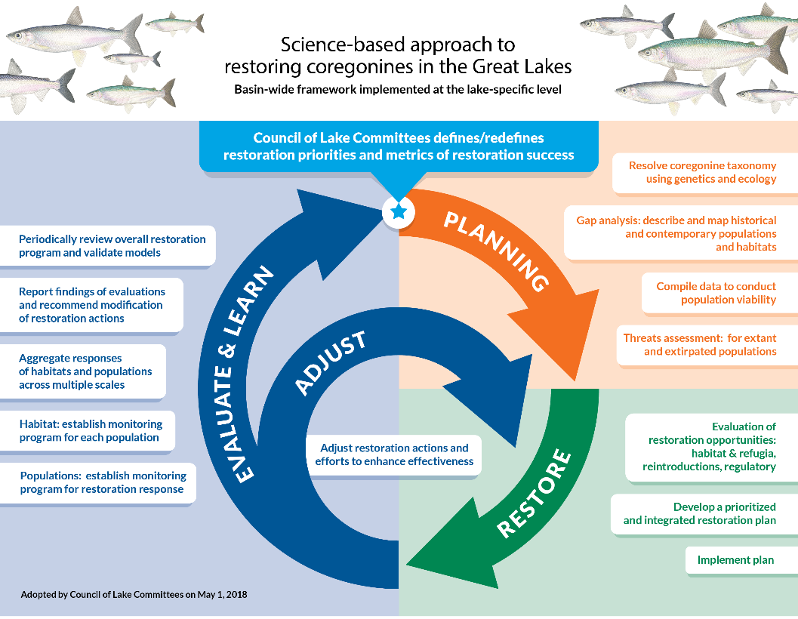
Duration of Funding: 1 year. Projects that are designed to be multi-year can be submitted for additional years after their first year is funded.
Timeline:
- RFP Solicitation announced: June 3
- Deadline to submit draft proposals to your Bureau coordinator: July 24
- Bureau-specific review of submitted proposals (and opportunities to look for replication within or between bureaus): July 27-August 14
- Bureau coordinators submit revised proposals to Coregonine Steering Committee co-chairs (Bo Bunnell, Jessica Hogrefe): August 28
- Coregonine Steering Committee decision meeting: September 15-16
- PI notifications of recommendations to EPA Focus Area 4: early October
Guidelines for Proposals
- Total length of the proposal text may not exceed 3 pages, single spaced, with 1-inch margins, and 12-point Times New Roman font. References and Budget and Justification do not count towards the 3-page limit.
- Any graphics, photos, tables, graphs, and charts must be embedded directly in the proposal document and be specifically referenced at least once in the body of the proposal. All graphics must be accompanied by a caption that describes the graphic. These count towards the total number of pages allotted.
- Proposals must follow the attached template.
- Letters of support from management agencies are not required, but if they are added please limit the number to three.
Criteria for Evaluating Proposals
- Proposal has tight alignment with the CRF and/or the priorities identified in this RFP.
- Proposal emphasizes lake-specific activities transferable to other lakes and/or coregonine species
- Proposal demonstrates support of the key principles of conservation biology and restoration ecology being applied to Coregonine restoration
- Proposal demonstrates collaboration among agencies and partners
- Proposal leaders have demonstrated technical expertise to complete the project or have co-investigators or appropriate partnerships with other organizations to meet all the requirements of the project
- For research proposals, hypotheses are clearly stated and tied to objectives
- Objectives are sound and achievable
- Methods are appropriate to achieve the proposed objectives
- Proposal supports previously funded work and complements ongoing research
- Deliverables fill a gap in knowledge or satisfy a need identified in the CRF
- Proposal budget is appropriate for the research proposed.
- Proposal has cost-share contributions or leverages other funding sources
- Proposal has a feasible completion timeframe given the objectives and methods of the project
- Proposal adheres to the format guidelines. Those that do not adhere to guidance will not be considered for funding.
- For investigators that have been awarded previous funding, the timeliness and outcomes of their projects will be considered for new proposals.

[Proposal Template]
Title: Use a short, descriptive title that captures the project purpose or goal. Please note if this is additional years of funding from a previously funded proposal (i.e., Year 2 of ….).

INVESTIGATOR(s): Include the name (in bold), agency or organization and email of only the Principal Investigator. List only the name and email of other investigators.

type: Indicate whether the project is research (hypotheses-based) or operational (i.e., field assessment, stocking, etc).

PERIOD: [Start date MM/YY- End date (MM/YY), FY27]. Please note that funding will arrive between May and August 2027.

One-year COST: Provide the total project cost, summing across agencies, if relevant. Funding requests for staff already supported full-time on base funds should not be made. Funding for temporary positions (e.g., post-doctoral scientists, contract staff, students) can be requested.

DESCRIPTION: Briefly describe the project and its rationale, including the alignment to the CRF or the priority indicated in the RFP. Justify why this project should be conducted and how its outcomes could be significant. If the proposal is for additional funding of a previously funded project, address how this project leverages that work. In most cases, it is probably not necessary to provide commonly understood background on the importance of coregonines, their demise, and the resurgence of restoration interest etc. as the committee is aware of these facts.

Objectives/tasks: List the project objectives (for research proposals) or tasks (for operational proposals). Project objectives are statements related to effectively advancing the CRF or priorities of the RFP based on interpretation of results. Descriptive objectives are acceptable when appropriate. For operational tasks, list the specific tasks. A set of objectives or tasks are ideally related to each other.

Hypotheses: For research-type projects only, describe the hypotheses to be evaluated for the relevant objectives. Provide some idea of the expected outcome or directionality of the hypotheses being tested.

Methods: Provide an overview of proposed methods for achieving each objective or task. For research projects and specific analyses called out in the CRF, include study design, data collection procedures, and analytical methods as appropriate.

Relevance: Description of how the project aligns with the CRF or the priorities in this RFP.

Deliverables/ManAgement outcomes: Provide a concise description of the type of reports, investigation data/information, and products that will be provided. All projects will require a final report of findings or outcomes describing what was done and how they relate to what was proposed.

REFERENCES: If applicable. These do not count against the 3-page limit.

BUDGET TABLE AND JUSTIFICATION: On separate pages (that do not count against the 3-page limit), fill in the budget table (using template below) to document annual budget requests. Below the table, provide a detailed budget justification for each budget category request. Please also indicate whether the project is scalable (i.e., it could be reduced to a lower budget amount), and if so, the impact of that scaling. Should funding go to multiple agencies, please denote funding requests specific to each agency by having a separate budget table and justification for each agency. Importantly, make sure the total one-year cost (in the proposal heading) is the sum of the total costs of all agencies.

Note: Reminder that funding salary of permanent federal employees already on base funding is not permitted. Funding for federal employees on Term or Temporary positions that are funded through reimbursable dollars is permitted.

Category (column 1): Use these budget categories.
Amount (column 2): The full dollar amount of all items in each category.
Scalability (column 3): Include the full dollar amount that the project could potentially be reduced by if not funded at the full amount requested.
Impact (column 4): Briefly describe the impact the reduced, scaled amount in column 3 would have on the project outcome, i.e., what would not be accomplished at a reduced cost.

Budget Table:
CATEGORY | AMOUNT | SCALABILITY | IMPACT
Personnel:

Personnel benefits:

Contracts:

Supplies:

Travel:

Equipment:

Others:

Indirect Costs:

TOTAL:

Budget Justification should justify and describe amounts for every row in the above table for which funding is requested.

